**Spring REST Handson**

**Hands on 1**

**Create a Spring Web Project using Maven**

**Code:**

package com.cognizant.springlearn;

import org.springframework.boot.SpringApplication;

import org.springframework.boot.autoconfigure.SpringBootApplication;

@SpringBootApplication

public class SpringLearnApplication {

public static void main(String[] args) {

System.out.println("Main() method started");

SpringApplication.run(SpringLearnApplication.class, args);

}

}

**Output:**

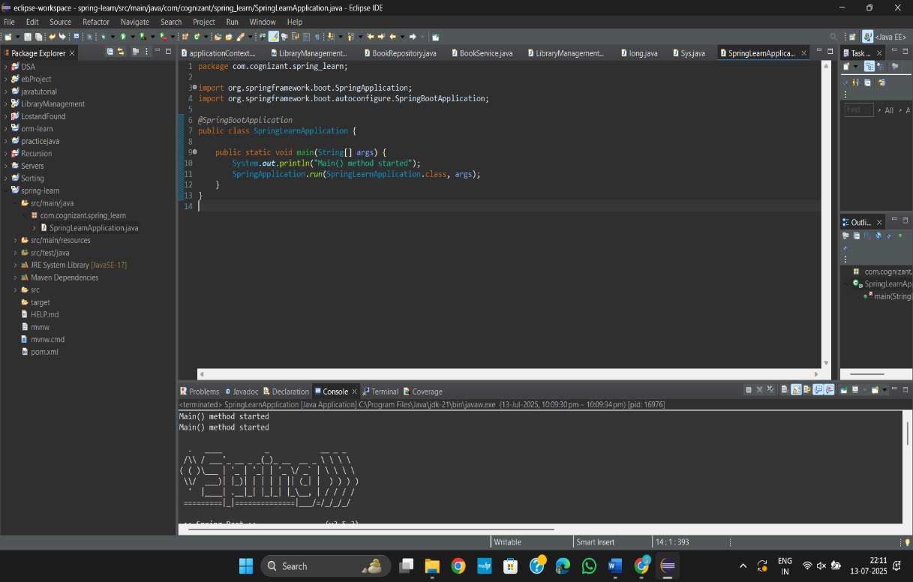

**Hands on 2**

**Spring Core – Load SimpleDateFormat from Spring Configuration XML**

**Code:**

**Date-format.xml**

<?xml version="1.0" encoding="UTF-8"?>

<beans xmlns="http://www.springframework.org/schema/beans"

xmlns:xsi="http://www.w3.org/2001/XMLSchema-instance"

xsi:schemaLocation="http://www.springframework.org/schema/beans

https://www.springframework.org/schema/beans/spring-beans.xsd">

<bean id="dateFormat" class="java.text.SimpleDateFormat">

<constructor-arg value="dd/MM/yyyy" />

</bean>

</beans>

**SpringLearnApplication.java**

package com.cognizant.springlearn;

import java.text.ParseException;

import java.text.SimpleDateFormat;

import java.util.Date;

import org.springframework.context.ApplicationContext;

import org.springframework.context.support.ClassPathXmlApplicationContext;

import org.springframework.boot.SpringApplication;

import org.springframework.boot.autoconfigure.SpringBootApplication;

@SpringBootApplication

public class SpringLearnApplication {

public static void main(String[] args) {

SpringApplication.run(SpringLearnApplication.class, args);

displayDate();

}

public static void displayDate() {

ApplicationContext context = new ClassPathXmlApplicationContext("date-format.xml");

SimpleDateFormat format = context.getBean("dateFormat", SimpleDateFormat.class);

try {

Date date = format.parse("31/12/2018");

System.out.println("Parsed Date: " + date);

} catch (ParseException e) {

System.out.println("Date parsing failed: " + e.getMessage());

}

}

}

**Output:**

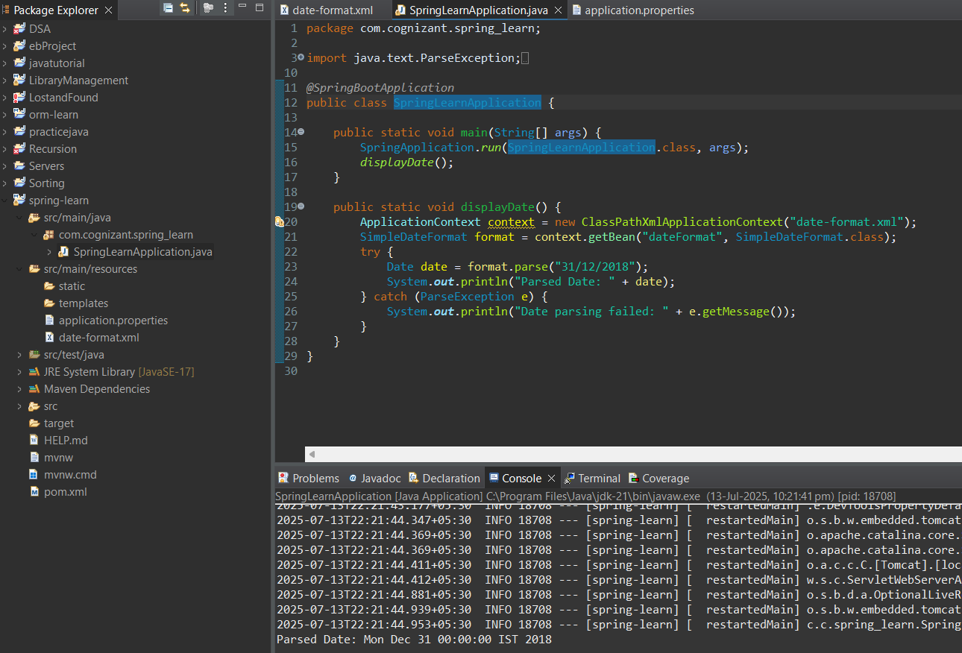

**Hello World RESTful Web Service   
Code:**

**HelloController.java**

package com.cognizant.springlearn;

import org.springframework.web.bind.annotation.GetMapping;

import org.springframework.web.bind.annotation.RestController;

@RestController

public class HelloController {

@GetMapping("/hello")

public String sayHello() {

System.out.println("START - sayHello()");

String message = "Hello World!!";

System.out.println("END - sayHello()");

return message;

}

}

**SpringLearnApplication.java**

package com.cognizant.springlearn;

import org.springframework.boot.SpringApplication;

import org.springframework.boot.autoconfigure.SpringBootApplication;

@SpringBootApplication

public class SpringLearnApplication {

public static void main(String[] args) {

SpringApplication.run(SpringLearnApplication.class, args);

}

}

**Output:**

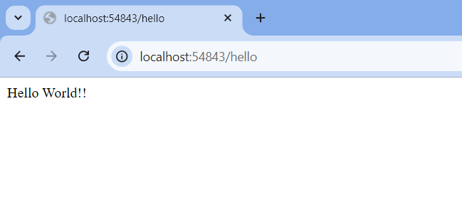

**REST - Country Web Service**

**Code:**

**Country.java**

package com.cognizant.springlearn.model;

public class Country {

private String code;

private String name;

public Country() {}

public Country(String code, String name) {

this.code = code;

this.name = name;

}

public String getCode() {

return code;

}

public void setCode(String code) {

this.code = code;

}

public String getName() {

return name;

}

public void setName(String name) {

this.name = name;

}

}

**Country.xml**

<?xml version="1.0" encoding="UTF-8"?>

<beans xmlns="http://www.springframework.org/schema/beans"

xmlns:xsi="http://www.w3.org/2001/XMLSchema-instance"

xsi:schemaLocation="http://www.springframework.org/schema/beans

https://www.springframework.org/schema/beans/spring-beans.xsd">

<bean id="countryList" class="java.util.ArrayList">

<constructor-arg>

<list>

<bean class="com.cognizant.springlearn.model.Country">

<property name="code" value="IN"/>

<property name="name" value="India"/>

</bean>

<bean class="com.cognizant.springlearn.model.Country">

<property name="code" value="US"/>

<property name="name" value="United States"/>

</bean>

<bean class="com.cognizant.springlearn.model.Country">

<property name="code" value="JP"/>

<property name="name" value="Japan"/>

</bean>

<bean class="com.cognizant.springlearn.model.Country">

<property name="code" value="DE"/>

<property name="name" value="Germany"/>

</bean>

</list>

</constructor-arg>

</bean>

</beans>

**CountryController.java**

package com.cognizant.springlearn.controller;

import java.util.List;

import com.cognizant.springlearn.model.Country;

import org.springframework.context.ApplicationContext;

import org.springframework.context.support.ClassPathXmlApplicationContext;

import org.springframework.web.bind.annotation.GetMapping;

import org.springframework.web.bind.annotation.RestController;

@RestController

public class CountryController {

@GetMapping("/countries")

public List<Country> getAllCountries() {

ApplicationContext context = new ClassPathXmlApplicationContext("country.xml");

List<Country> countryList = context.getBean("countryList", List.class);

return countryList;

}

}

**SpringLearnApplication.java**

package com.cognizant.springlearn;

import org.springframework.boot.SpringApplication;

import org.springframework.boot.autoconfigure.SpringBootApplication;

@SpringBootApplication

public class SpringLearnApplication {

public static void main(String[] args) {

SpringApplication.run(SpringLearnApplication.class, args);

}

}

**Output:**

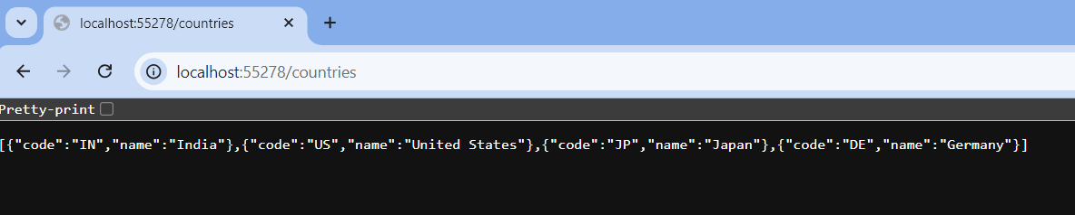

**REST - Get country based on country code**

**Code:**

**Country.java**

package com.cognizant.springlearn.model;

public class Country {

private String code;

private String name;

public Country() {}

public Country(String code, String name) {

this.code = code;

this.name = name;

}

public String getCode() {

return code;

}

public void setCode(String code) {

this.code = code;

}

public String getName() {

return name;

}

public void setName(String name) {

this.name = name;

}

}

**country.xml**

<?xml version="1.0" encoding="UTF-8"?>

<beans xmlns="http://www.springframework.org/schema/beans"

xmlns:xsi="http://www.w3.org/2001/XMLSchema-instance"

xsi:schemaLocation="http://www.springframework.org/schema/beans

https://www.springframework.org/schema/beans/spring-beans.xsd">

<bean id="countryList" class="java.util.ArrayList">

<constructor-arg>

<list>

<bean class="com.cognizant.springlearn.model.Country">

<property name="code" value="IN"/>

<property name="name" value="India"/>

</bean>

<bean class="com.cognizant.springlearn.model.Country">

<property name="code" value="US"/>

<property name="name" value="United States"/>

</bean>

<bean class="com.cognizant.springlearn.model.Country">

<property name="code" value="JP"/>

<property name="name" value="Japan"/>

</bean>

<bean class="com.cognizant.springlearn.model.Country">

<property name="code" value="DE"/>

<property name="name" value="Germany"/>

</bean>

</list>

</constructor-arg>

</bean>

</beans>

**CountryService.java**

package com.cognizant.springlearn.service;

import com.cognizant.springlearn.model.Country;

import org.springframework.context.ApplicationContext;

import org.springframework.context.support.ClassPathXmlApplicationContext;

import org.springframework.stereotype.Service;

import java.util.List;

@Service

public class CountryService {

public Country getCountry(String code) {

ApplicationContext context = new ClassPathXmlApplicationContext("country.xml");

List<Country> countryList = context.getBean("countryList", List.class);

return countryList.stream()

.filter(c -> c.getCode().equalsIgnoreCase(code))

.findFirst()

.orElse(null); // or throw exception if needed

}

}

**CountryController.java**

package com.cognizant.springlearn.controller;

import com.cognizant.springlearn.model.Country;

import com.cognizant.springlearn.service.CountryService;

import org.springframework.beans.factory.annotation.Autowired;

import org.springframework.web.bind.annotation.*;

@RestController

public class CountryController {

@Autowired

private CountryService countryService;

@GetMapping("/countries/{code}")

public Country getCountry(@PathVariable String code) {

return countryService.getCountry(code);

}

}

**Output:**

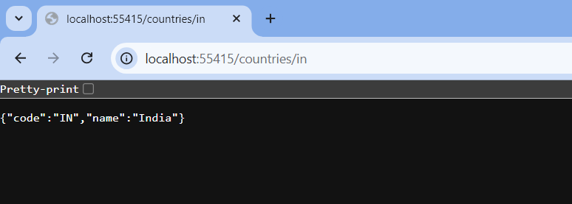

**Create authentication service that returns JWT**

**Code:**

**AuthenticationController**

package com.cognizant.springlearn.controller;

import com.cognizant.springlearn.util.JwtUtil;

import jakarta.servlet.http.HttpServletRequest;

import org.springframework.http.ResponseEntity;

import org.springframework.web.bind.annotation.*;

import java.util.Base64;

@RestController

public class AuthenticationController {

@GetMapping("/authenticate")

public ResponseEntity<?> authenticate(HttpServletRequest request) {

String authHeader = request.getHeader("Authorization");

if (authHeader == null || !authHeader.startsWith("Basic ")) {

return ResponseEntity.status(401).body("Missing or invalid Authorization header.");

}

// Decode credentials

String base64Credentials = authHeader.substring("Basic ".length()).trim();

byte[] credDecoded = Base64.getDecoder().decode(base64Credentials);

String credentials = new String(credDecoded);

// Split username and password

final String[] values = credentials.split(":", 2);

String username = values[0];

String password = values[1];

// Validate hardcoded credentials (for now)

if (!"user".equals(username) || !"pwd".equals(password)) {

return ResponseEntity.status(401).body("Invalid credentials");

}

// Generate token

String token = JwtUtil.generateToken(username);

return ResponseEntity.ok().body("{\"token\":\"" + token + "\"}");

}

}

**JwtUtil.java**

package com.cognizant.springlearn.util;

import io.jsonwebtoken.Jwts;

import io.jsonwebtoken.SignatureAlgorithm;

import java.util.Date;

public class JwtUtil {

private static final String SECRET_KEY = "mySecretKey";

public static String generateToken(String username) {

return Jwts.builder()

.setSubject(username)

.setIssuedAt(new Date(System.currentTimeMillis()))

.setExpiration(new Date(System.currentTimeMillis() + 60 * 60 * 1000)) // 1 hour

.signWith(SignatureAlgorithm.HS256, SECRET_KEY)

.compact();

}

}

**SecurityConfig.java**

package com.cognizant.springlearn.config;

import org.springframework.context.annotation.Bean;

import org.springframework.context.annotation.Configuration;

import org.springframework.security.config.Customizer;

import org.springframework.security.web.SecurityFilterChain;

import org.springframework.security.config.annotation.web.builders.HttpSecurity;

@Configuration

public class SecurityConfig {

@Bean

public SecurityFilterChain filterChain(HttpSecurity http) throws Exception {

http

.csrf(csrf -> csrf.disable())

.authorizeHttpRequests(auth -> auth

.requestMatchers("/authenticate").permitAll()

.anyRequest().authenticated()

)

.httpBasic(Customizer.withDefaults());

return http.build();

}

}